Requirements and Guidelines for Abstract (Title May be Maximum Two Lines if Needed)

Presenting author's first name, initials and family name¹, Second author's first name initials and family name²
¹Presenting author's affiliation, City, Country
²Second author's affiliation, City, Country
E-mail: Presenting author's e-mail address

Use A4 (210 mm × 297mm) paper size. The abstract should be at least 200 words, but not exceeding one A4 page, including figures, with page margins of 2.5 mm all around. Use font type Times New Roman, with single spaced lines. The title of the paper (14 point, first letters capitalised, centred) may span a maximum of two lines, and is followed by one blank line. Authors’ names are written (12 point, centred) with initials followed by dot, family names are written in full. Authors are separated by commas and marked with superscript when necessary to distinguish authors from different affiliations. The presenting author’s name should be underlined and given as first author in the list. Authors’ affiliations (12 point, italic, centred) are written on separate lines when there are more than one and the last is followed by the presenting author’s email address and two blank lines. Abstract text (12 point) is justified on both sides; paragraphs are not indented, only separated by one blank line. References should be indicated in the text in square brackets and listed at the end of the paper (11 point) [1-3]. Figures should be placed preceding the reference list.

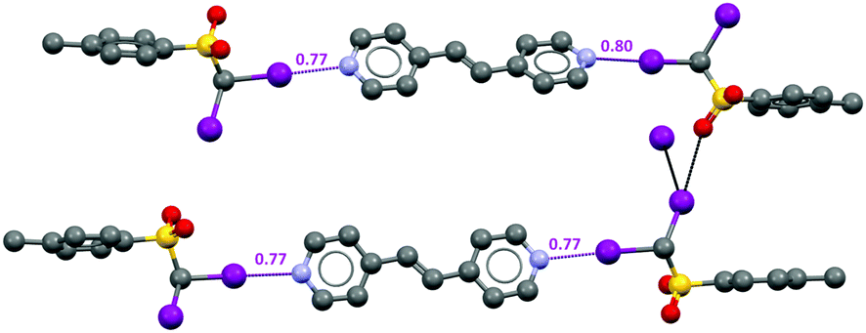

Figure 1: Co-crystal of diiodomethyl-p-tolylsulfone (DMTS) and 1,2-bis(4-pyridyl)ethylene.

References
- A.A. Author, B.B. Author, C.C. Author, Journal Title year, volume, first page-last page.
- A.A. Author, B.B. Author, C.C. Author, Book Title, Publisher, city, year of publication.
- A.A. Author, B.B. Author, C.C. Author, Chapter Title, in: Book Title, Eds. X.X. Editor, Y.Y. Editor, Publisher, year, city; pages: first page-last page.

